

**North South University**

# Department of Electrical & Computer Engineering

**LAB REPORT**

Course Code: EEE141L

Course Title: Electrical Circuits I Lab

Course Instructor: Dr. Mohammad Abdul Matin (Mtn)

Experiment Number: 4

Experiment Name:

|  |
| --- |
| Delta-Wye Conversion |

Experiment Date: 25/3/2021

Date of Submission: 31/3/2021

Section: 3

Submitted To: Tabia Hossain

|  |  |
| --- | --- |
| Submitted By | Score |
| Student Name and ID:  1. Md. Rifat Ahmed - 1931725042 |  |

**Objectives:**

• To perform Delta-Wye Conversion.

• To verify the results with measured data.

• Solve a complex circuit using Delta-Wye Conversion.

**List of Equipment:**

• OrCAD Software

• PSpice Simulation Software

• 5 × 15kΩ resistors

• 3 × 5kΩ resistor

• Connecting wire

**Theory:**

**Delta-Wye Conversion:**

The Delta-Wye (∆-Y) conversion is a special technique used to handle complex circuits that cannot be handled by the usual series, parallel combinations, where we’re not sure if the resistors are connected in series or parallel.

This transformation allows us to replace three resistors in a ‘∆’ configuration into a ‘Y’ configuration and the other way around.

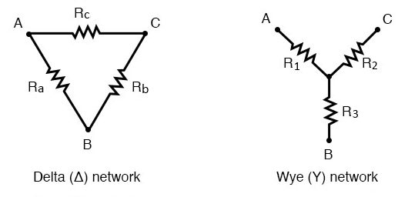

Figure: ∆-Y Network Configuration

These configurations can be redrawn to square up the resistors which is why this ∆-Y conversion is also called Pi-T (π-T) conversion.

And the π-T configurations looks like the following figure.

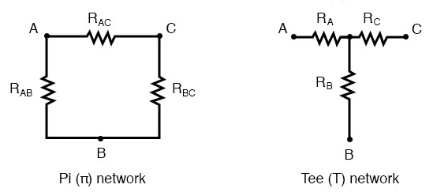

Figure: π-T Network Configuration

**Delta (∆) → Wye (Y) Transformation:**

The equations to transform a ∆ network into a Y network are,

R1 =

R2 =

R3 =

However, transforming a ∆ network into a Y network introduces one additional node in the circuit. And these equations also apply for the π-T configuration as that’s nothing but a redrawn state of the ∆-Y transformation.

Now, there’s a shortcut to the ∆-Y conversion. If the ∆ configuration has the three resistors with the same amount of resistance then we can calculate the resistances for Y configuration just by dividing any of the Ra/Rb/Rc by 3 and that’ll be the resistance of R1=R2=R3.

؞Y = 1/3 ∆

* ∆ = 3Y

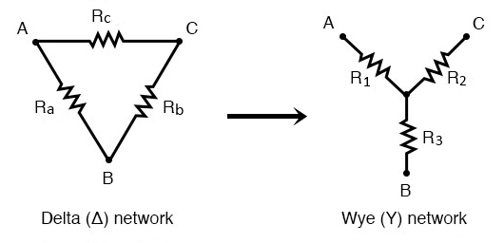

Figure: Delta (∆) to Wye (Y) Conversion

**Wye (Y) → Delta (∆) Transformation:**

And now the equations to transform from Y configuration to ∆ configuration,

Ra = $\frac{R1R2+R2R3+R3R1}{R2}$

Rb = $\frac{R1R2+R2R3+R3R1}{R1}$

Rc = $\frac{R1R2+R2R3+R3R1}{R3}$

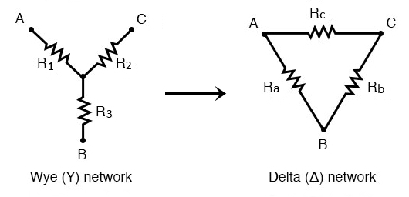

Figure: Wye (Y) to Delta (∆) Conversion

**Circuit Diagram:**

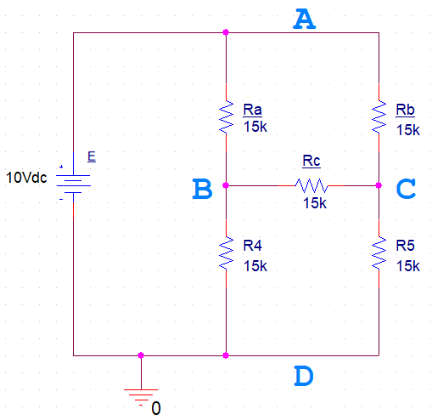

**Circuit – 1**

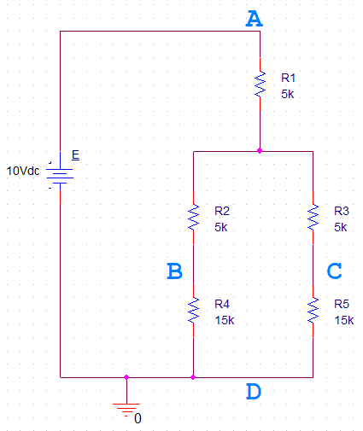

**Circuit – 2**

**Data, Readings and Results:**

**Table 1:**

|  |  |  |
| --- | --- | --- |
| **Theoretical R** | **Measured R** | **% Error** |
| **15k** | 15k | 0% |
| **5k** | 5k | 0% |

**Table 2:**

|  |  |  |  |
| --- | --- | --- | --- |
| **Readings** | **Circuit 1** | **Circuit 2** | **% Error** |
| **VAD** | 10V | 10V | 0% |
| **VBD** | 5V | 5V | 0% |
| **VCD** | 5V | 5V | 0% |
| **VAB** | 5V | 5V | 0% |
| **VBC** | 0V | 0V | 0% |
| **VAC** | 5V | 5V | 0% |

**Questions and Answers:**

**Q&A for Circuit 1:**

**Answer of Question 1:**

The resistors in Circuit 1 are in a complex circuit which is neither series nor parallel combination.

**Answer of Question 2:**

I would use the Delta-Wye conversion technique to find the equivalent resistance.

**Answer of Question 3:**

Performing the Delta-Wye conversion for ∆ABC in Circuit – 1:

Given,

Ra = 15kΩ

Rb = 15kΩ

Rc = 15kΩ

R1 = = = 5kΩ

R2 = = = 5kΩ

R3 = = = 5kΩ

**Q&A for Circuit 2:**

**Answer of Question 1:**

Redrawing the equivalent circuit after applying the Delta-Wye conversion for ∆ABC,



And it is the same as Circuit – 2.

**Answer of Question 2:**

Given,

R1 = 5kΩ

R2 = 5kΩ

R3 = 5kΩ

R4 = 15kΩ

R5 = 15kΩ

Here, R2, R4 and R3, R5 are in series,

؞ RS1 = R2+R4 = 5+15 = 20kΩ

؞ RS2 = R3+R5 = 5+15 = 20kΩ

Now, RS1 and RS2 are in parallel,

؞ RP = RS1 || RS2 = = = 10kΩ

And finally, R1 and RP are in series,

؞ Req = R1 + RP = 5+10 = 15kΩ

**Answer of Question 3:**

Calculating the voltages for R1, R2 and R3,

For R1,

VR1 = = = 3.33V

For R2,

VR2 = VAB – VR1 = 5–3.33 = 1.67V

For R3,

VR3 = VR2 = 1.67V

**Answer of Question 4:**

Given,

E = 10V

VA = E = 10V

VB = E – VR1 – VR2

= 10 - 3.33 - 1.67 = 5V

VC = VB = 5V

VD = E – (IT × Req)

= E – ( $\frac{E}{Req}$ × Req) = 10 – 10 = 0V

VAB = 10-5 = 5V

VBC = 5-5 = 0V

VAC = 10-5 = 5V

VAD = 10-0 = 10V

VBD = 5-0 = 5V

VCD = 5-0 = 5V

؞ % Error for VAB = × 100%

= $|\frac{5-5}{5}|$ × 100% = 0%

؞ % Error for VBC = × 100% = 0%

؞ % Error for VAC = × 100% = 0%

؞ % Error for VAD = × 100% = 0%

؞ % Error for VBD = × 100% = 0%

؞ % Error for VCD = × 100% = 0%

**Answer of Question 5:**

Using Table 2 we can clearly say that Circuit 2 is equivalent to Circuit 1. And from the percentage error column we can see that the error percentage is zero for all the readings, which indicates that both the circuit has same amount of voltages running across them for all VAB, VBC, VAC, VAD, VBD and VCD. So, the Delta-Wye conversion was definitely successful.

**Discussion:**

From this experiment we’ve learned the Delta-Wye conversion and Wye-Delta conversion. Using this technique, we can calculate complex circuits where the resistors connection can’t be figured out. For out circuit – 1 it wasn’t clear if Ra, Rb and Rc were in series or parallel but after performing Delta-Wye conversion we could easily calculate the equivalent resistance Req of our circuit. However, this conversion knowledge will not only help us for this experiment but will also help us in the future with bigger or more complex circuits. And as for the result, we got no % error which indicates that our Delta-Wye conversion was successful. And during this experiment we didn’t face any problem as everything was clear and understandable during the class.